Belmont City College 2023
Year 12 ATAR Human Biology Unit 3
Task 2 Part A: Test – Endocrine System

Name: ………………………………………….………….. Total Mark /40

Section One: Multiple Choice (10 Marks)
Place a cross (X) through the selected letter:
1. A B C D 6. A B C D
2. A B C D 7. A B C D
3. A B C D 8. A B C D
4. A B C D 9. A B C D
5. A B C D 10. A B C D

Section Two: Short Answer (20 Marks)
Question 11 (15 marks)
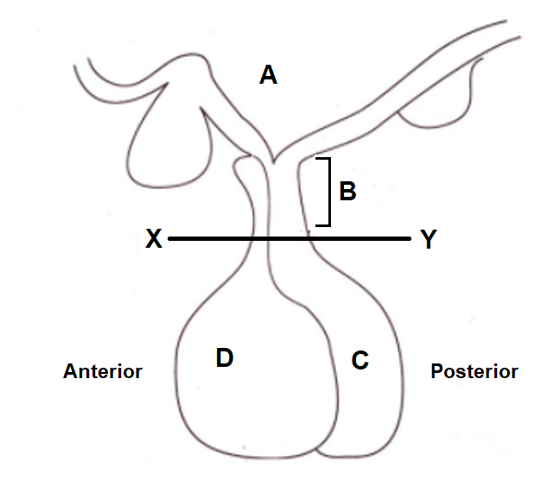
Refer to the diagram below and answer the questions that follow.

- The structure labelled ‘B’ is the ………………………………………………………... (1 mark)
- If a cut is made at line XY, what effect will this have on the function of ‘C’? (1 mark)

………………………………………………………………………………………………………….

- Explain why the cut resulted in this effect. (2 marks)
………………………………………………………………………………………………………….
…………………………………………………………………………………………………………
- Explain the effect that this will have on the kidneys. (1 mark)

………………………………………………………………………………………………………….

- Explain the different methods ‘A’ uses to stimulate parts C and D, so they can release their respective chemicals. (4 marks)
………………………………………………………………………………………………………….
………………………………………………………………………………………………………….
………………………………………………………………………………………………………….
………………………………………………………………………………………………………….
………………………………………………………………………………………………………….

- Discuss in detail how the structure labelled D in the diagram above assists in regulating Basal Metabolic Rate. (6 marks)
……………………………………………………………………………………………………………………..
…………………………………………………………………………………………………………………….
…………………………………………………………………………………………………………………….
…………………………………………………………………………………………………………………….
……………………………………………………………………………………………………………………
……………………………………………………………………………………………………………………
…………………………………………………………………………………………………………………..
…………………………………………………………………………………………………………………..
…………………………………………………………………………………………………………………..
…………………………………………………………………………………………………………………..
…………………………………………………………………………………………………………………..
…………………………………………………………………………………………………………………..

Question 12 (5 marks)
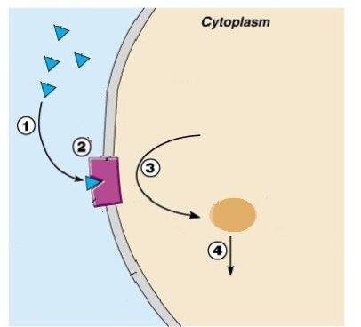

Using the diagram above, complete the following questions:
- At point 2, why is this hormone able to bind, but not other hormones? (1 mark)

…………………………………………………………………………………

- Describe what is occurring at points 1-4. (4 marks)

1
2
3
4

Section Three: Extended Answer
Question 13 (10 marks)
After fasting for a period of time, blood glucose levels fall. Describe the hormonal process involving the pancreas that brings blood glucose back to homeostatic levels, and what happens once the homeostatic set point is reached. (10 marks)
……………………………………………………………………………………………………………………………………….
……………………………………………………………………………………………………………………………………….
……………………………………………………………………………………………………………………………………….
……………………………………………………………………………………………………………………………………….
……………………………………………………………………………………………………………………………………….
……………………………………………………………………………………………………………………………………….
……………………………………………………………………………………………………………………………………….
……………………………………………………………………………………………………………………………………….
……………………………………………………………………………………………………………………………………….
……………………………………………………………………………………………………………………………………….
………………………………………………………………………………………………………………………………………
……………………………………………………………………………………………………………………………………….
……………………………………………………………………………………………………………………………………….
……………………………………………………………………………………………………………………………………….
……………………………………………………………………………………………………………………………………….
……………………………………………………………………………………………………………………………………….
……………………………………………………………………………………………………………………………………….
……………………………………………………………………………………………………………………………………….
……………………………………………………………………………………………………………………………………….
……………………………………………………………………………………………………………………………………….
……………………………………………………………………………………………………………………………………….
……………………………………………………………………………………………………………………………………….
………………………………………………………………………………………………………………………………………
……………………………………………………………………………………………………………………………………….

END OF TEST PAPER

